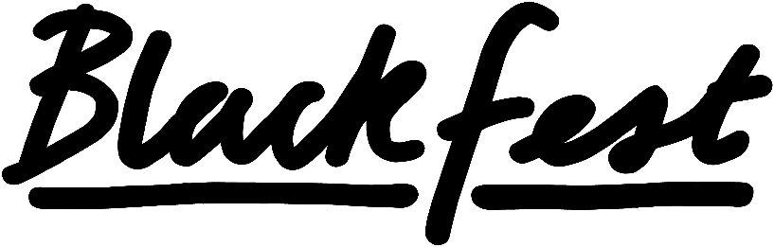

What is your artist name and please provide a short bio?
(Up to 200 words and no more)

What is your main passion within arts and why?

Which segment of the festival have you applied for?

We want to see audacious and experimental work challenging the boundaries of performance and experience for our audiences. Do you have a vision in mind for your performance? Please give a brief description of your ideas in 500 words or less.

Why would you like to be a part of BlackFest 2026?

Please can you provide links to your work:

